Squash and Pumpkin Variety Guide
 | Variety | Notes
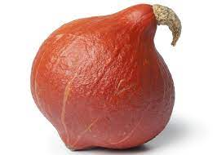 | Uchiki Kuri Squash | Versatile variety. Sweet, tender, and slightly floury, with soft edible skin. Large cavity makes it good for roasting in halves then stuffing.
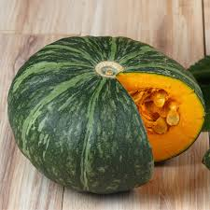 | Green Hokkaido Squash | Nutty, dry, dense yet fluffy. Superb flavour and great for roasting. Edible skin.
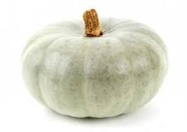 | Crown Prince Squash | A hefty squash, well suited for feasting! ITs pale skin hides bright orange flesh. A favourite of chefs for its superb nutty flavour. Try in risotto or roasted with cinnamon.
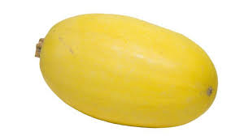 | Spaghetti Squash | Mild taste and makes a great healthy pasta substitute. Half lengthways, remove seeds, drizzle with oil and roast face down for about 45 mins, then tease out the strands with a fork – and voila… squashetti!
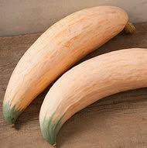 | Georgia Candy Roaster Squash | These whopping squash were first cultivated by the Cherokee, and are still a favourite in the US Southeast, where they are sometimes used in pumpkin pies. Sweet and smooth, pairs well with white beans in soups.
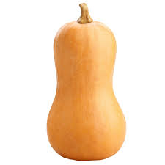 | Butternut Squash | Needs no introduction – and a firm favourite for a reason. Roast, bake, stuff or soup!
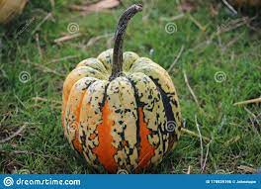 | Festival Squash | Acorn squash with amazing pattern on skin. Dense and nutty, great for roasting whole and stuffing
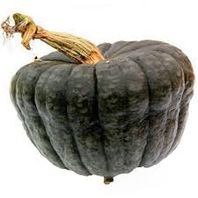 | Queensland Blue Squash | Mild tasting firm flesh, with perhaps a hint of lemon in the aftertaste. Nice in curries.
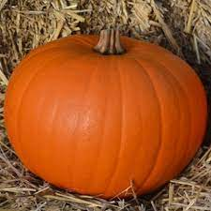 | Harvest Moon Pumpkin | The classic Halloween pumpkin, great for carving and for making pies
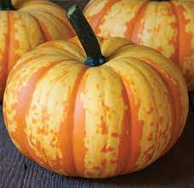 | Blaze Pumpkin | Striking ornamental variety – also good for making pumpkin bread!

